Tangency

Definition
# Source: AI Source: Provided by: [Data Path: Persons Table -> ID Column: 1, Name_En Column: Motasem Essam] -> From: [ChatGPT] on [7/25/2026]
Tangency is a geometric relationship in which two geometric objects touch at exactly one point without crossing each other at that point.
The common point is called the point of tangency or point of contact.
For example, when a line touches a circle at exactly one point:
$$\boxed{l∩C=P}$$
where $P$ is the point of tangency.
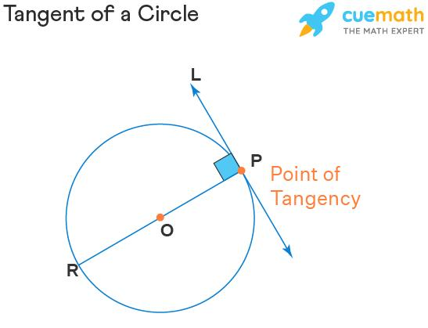
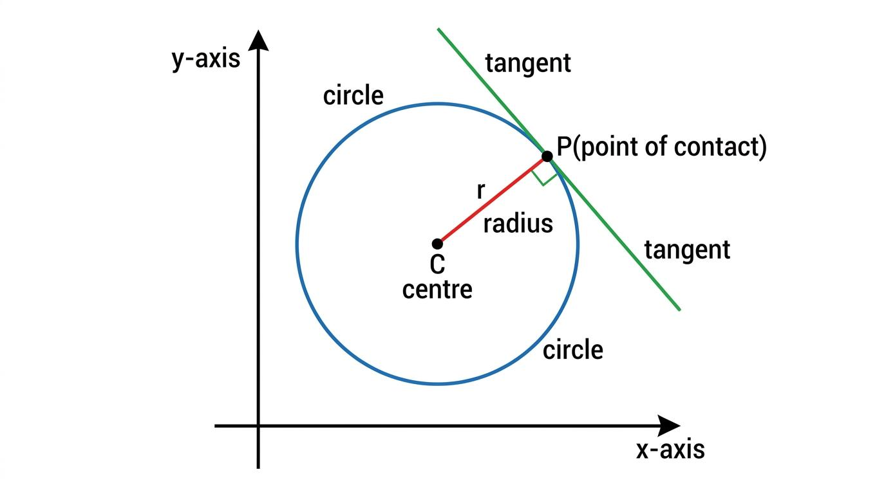
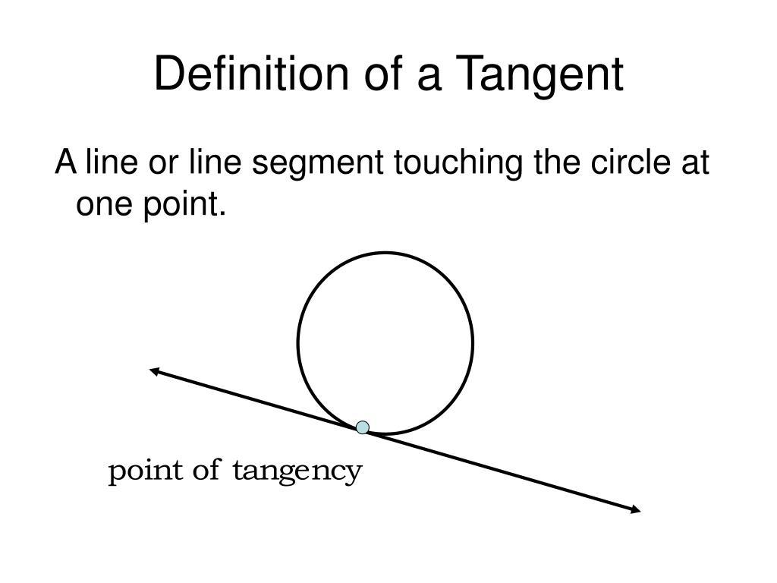
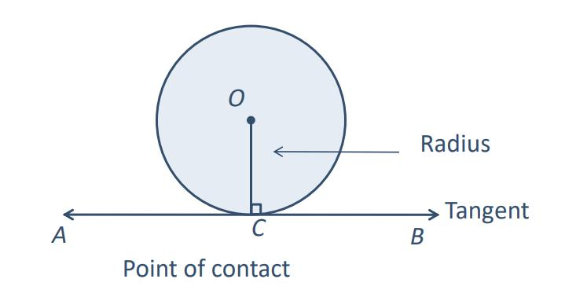
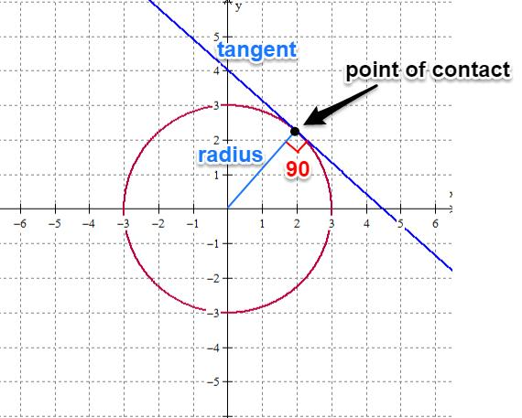

Purpose
# Source: AI Source: Provided by: [Data Path: Persons Table -> ID Column: 1, Name_En Column: Motasem Essam] -> From: [ChatGPT] on [7/25/2026]
Tangency is used to:
- Describe objects that touch without crossing.
- Analyze circles and tangent lines.
- Determine geometric constraints.
- Construct smooth connections between curves.
- Calculate distances and angles.
- Design wheels, gears, and mechanical parts.
- Create smooth curves in CAD.
- Analyze paths and boundaries.
- Solve geometry and trigonometry problems.

Fundamental Idea
# Source: AI Source: Provided by: [Data Path: Persons Table -> ID Column: 1, Name_En Column: Motasem Essam] -> From: [ChatGPT] on [7/25/2026]
The main idea of tangency is:
$$\boxed{\text{Touching at exactly one point}}$$
For example:
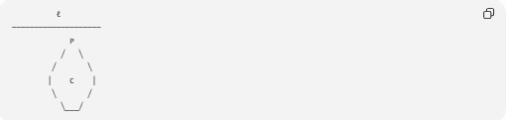
ℓ
────────────────────
P
╱ ╲
╱ ╲
│ C │
╲ ╱
╲___╱
The line $l$ touches the circle $C$ at $P$.
Therefore:
$$\boxed{l∩C=P}$$
The line does not pass through the interior of the circle.

Point of Tangency
# Source: AI Source: Provided by: [Data Path: Persons Table -> ID Column: 1, Name_En Column: Motasem Essam] -> From: [ChatGPT] on [7/25/2026]
The point where two tangent objects touch is called the:
$$\boxed{\text{Point of Tangency}}$$
or:
$$\boxed{\text{Point of Contact}}$$
For a circle and tangent line:
$$P=\text{point of tangency}$$
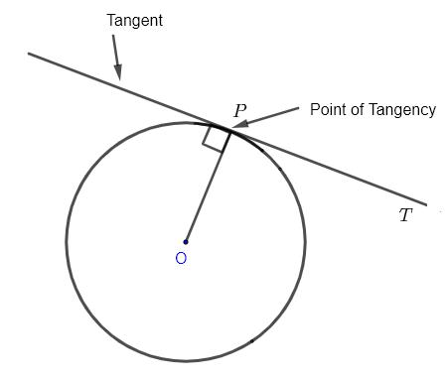
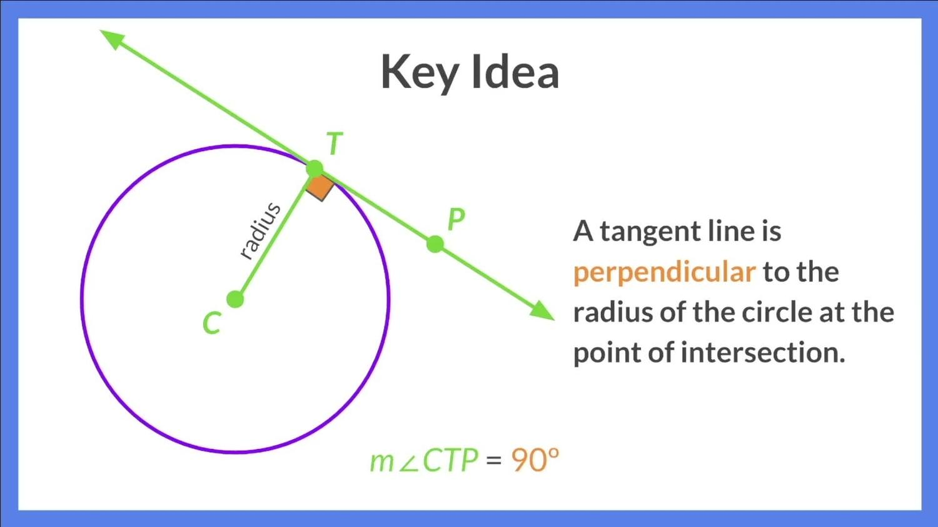
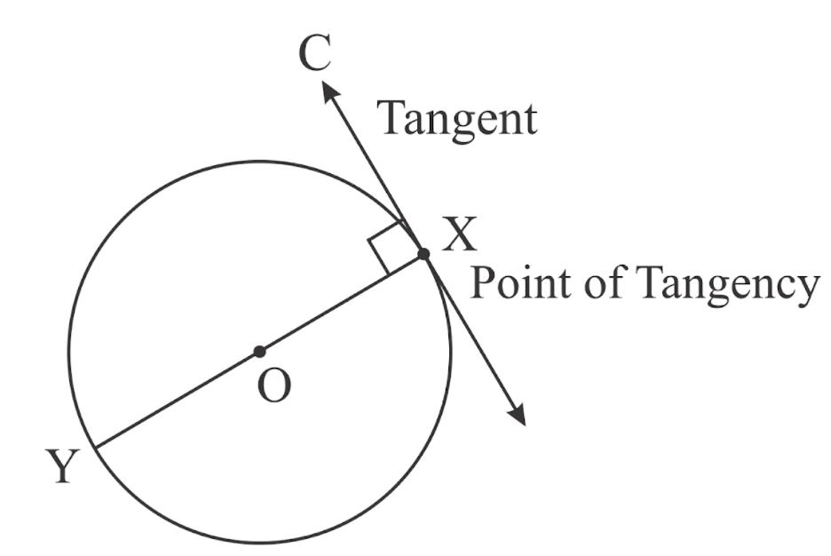

Tangent Line
# Source: AI Source: Provided by: [Data Path: Persons Table -> ID Column: 1, Name_En Column: Motasem Essam] -> From: [ChatGPT] on [7/25/2026]
A tangent line is a line that touches a circle at exactly one point.
If $l$ is tangent to circle $C$ at $P$:
$$\boxed{l∩C=P}$$
The tangent line has an important property:
$$\boxed{OP⊥l}$$
where:
- $O$ = center of the circle.
- $P$ = point of tangency.
- $l$ = tangent line.

Radius to the Point of Tangency
# Source: AI Source: Provided by: [Data Path: Persons Table -> ID Column: 1, Name_En Column: Motasem Essam] -> From: [ChatGPT] on [7/25/2026]
The radius drawn from the center to the point of tangency is perpendicular to the tangent line.
$$\boxed{OP⊥l}$$
Therefore, the angle between the radius and tangent is:
$$\boxed{{90}^{∘}}$$
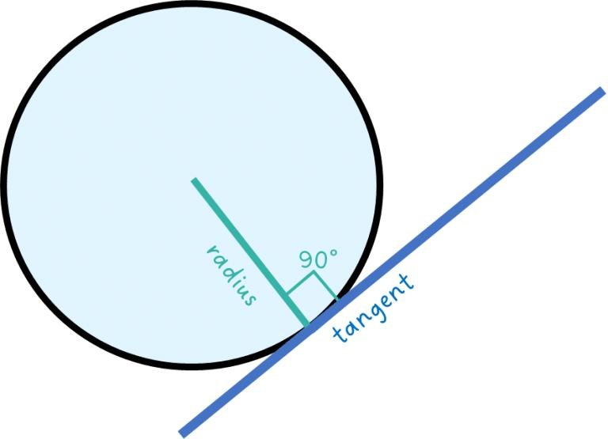
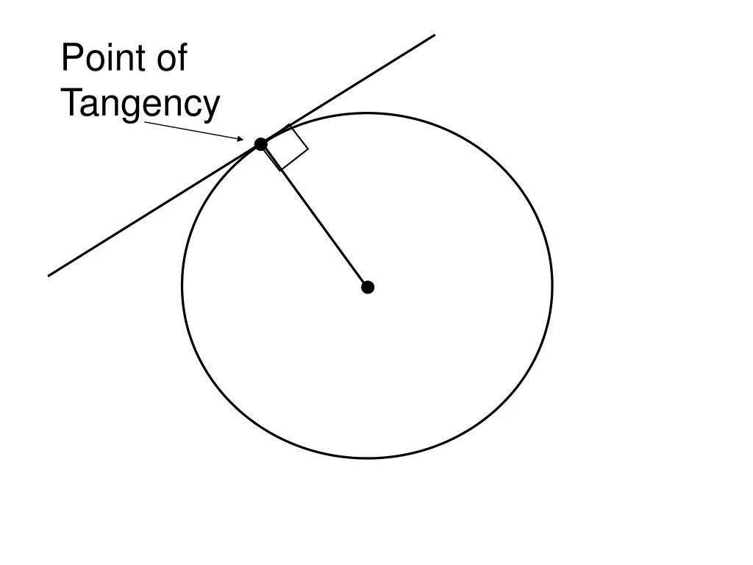
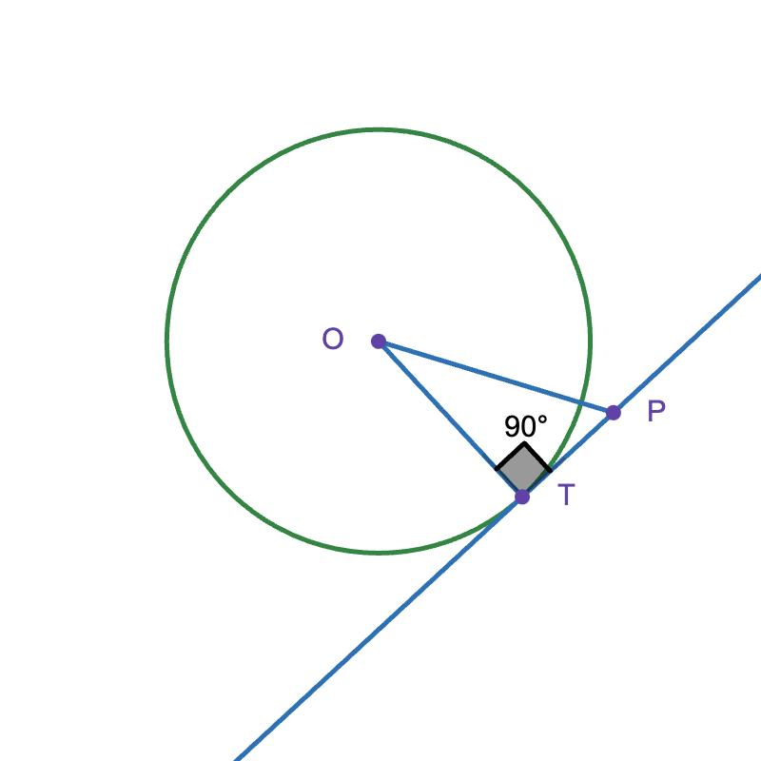
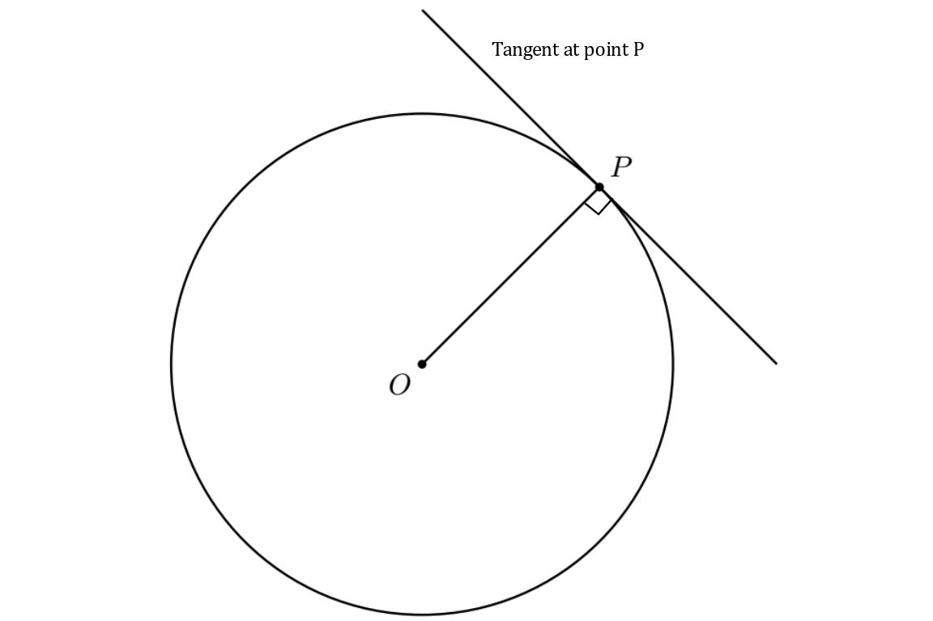
This is one of the most important properties of tangency.

Tangency Between Two Circles
# Source: AI Source: Provided by: [Data Path: Persons Table -> ID Column: 1, Name_En Column: Motasem Essam] -> From: [ChatGPT] on [7/25/2026]
Two circles can also be tangent to each other.
There are two main types:
- External Tangency
- Internal Tangency

1. External Tangency
# Source: AI Source: Provided by: [Data Path: Persons Table -> ID Column: 1, Name_En Column: Motasem Essam] -> From: [ChatGPT] on [7/25/2026]
Two circles are externally tangent when they touch at exactly one point from the outside.
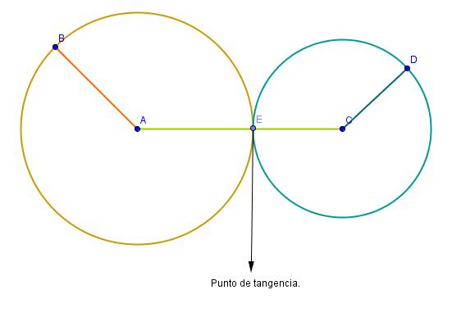
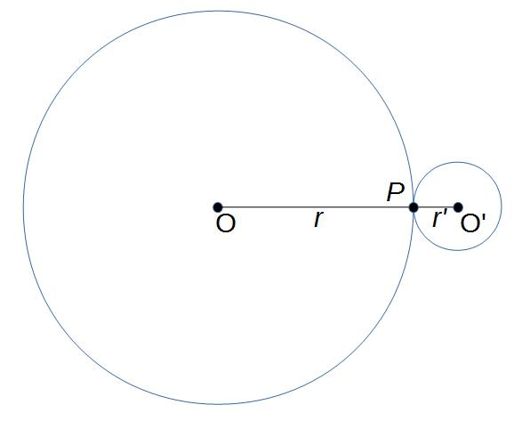
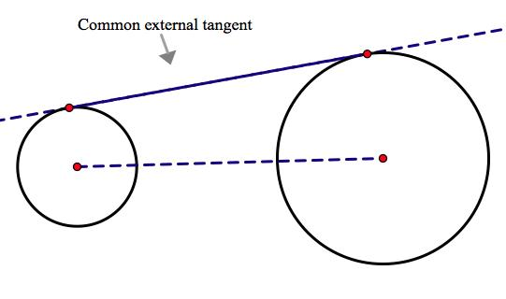
For circles with centers $O_{1}$ and $O_{2}$, radii $r_{1}$ and $r_{2}$:
$$\boxed{O_{1}O_{2}=r_{1}+r_{2}}$$
The distance between their centers equals the sum of their radii.

2. Internal Tangency
# Source: AI Source: Provided by: [Data Path: Persons Table -> ID Column: 1, Name_En Column: Motasem Essam] -> From: [ChatGPT] on [7/25/2026]
Two circles are internally tangent when one circle lies inside the other and they touch at exactly one point.
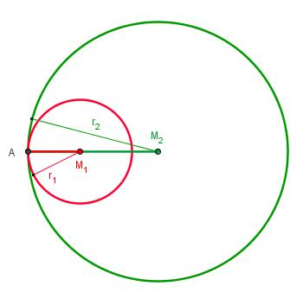
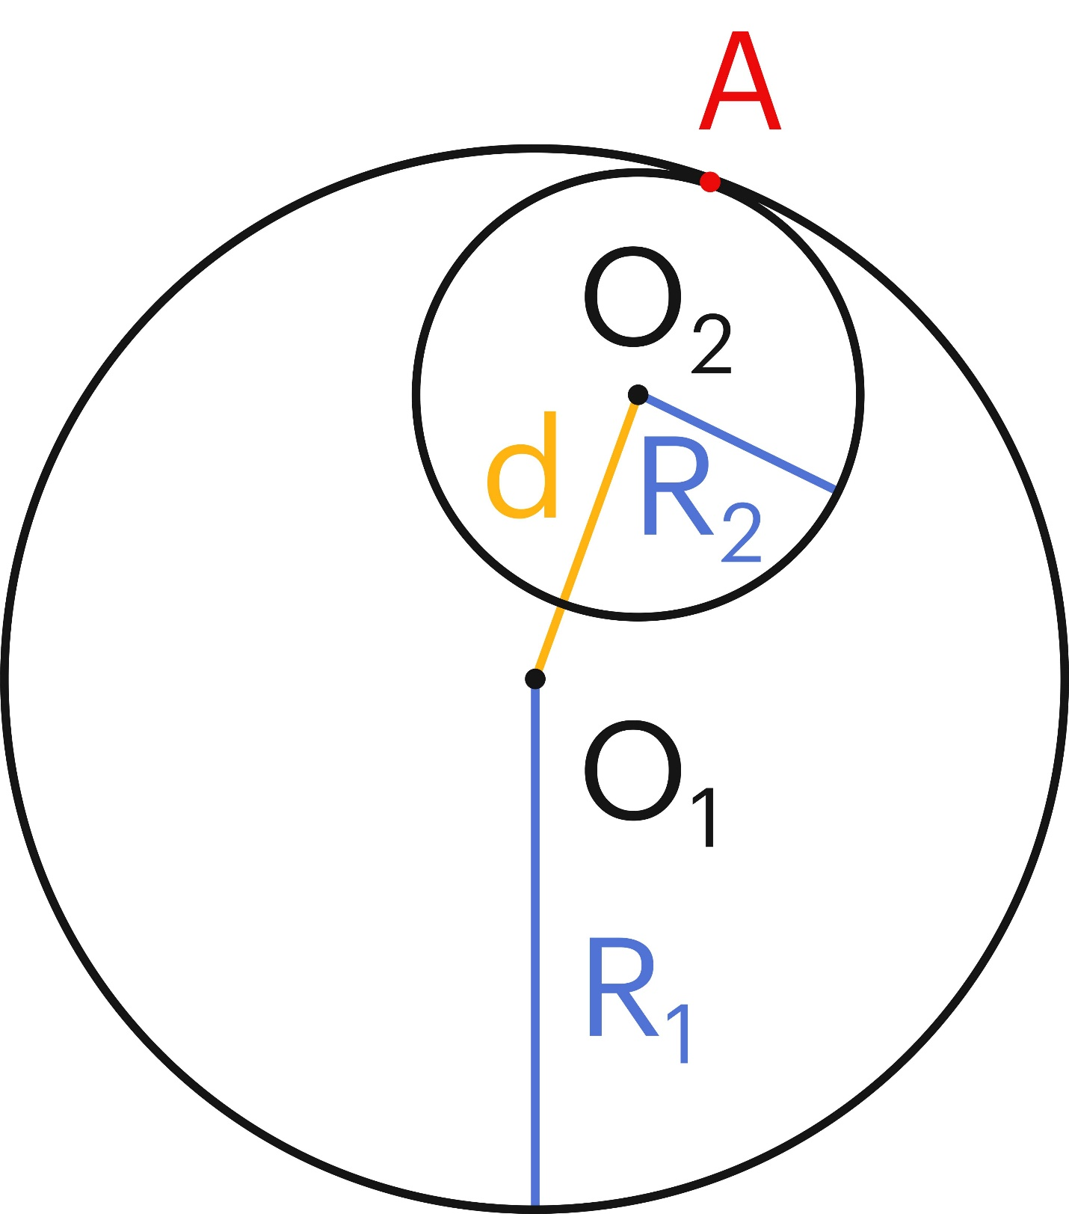
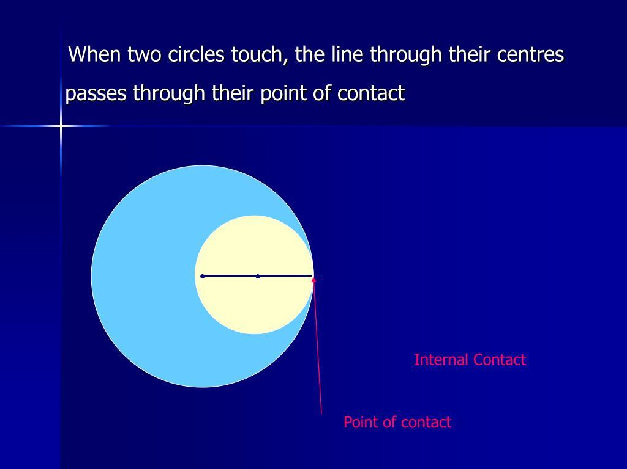
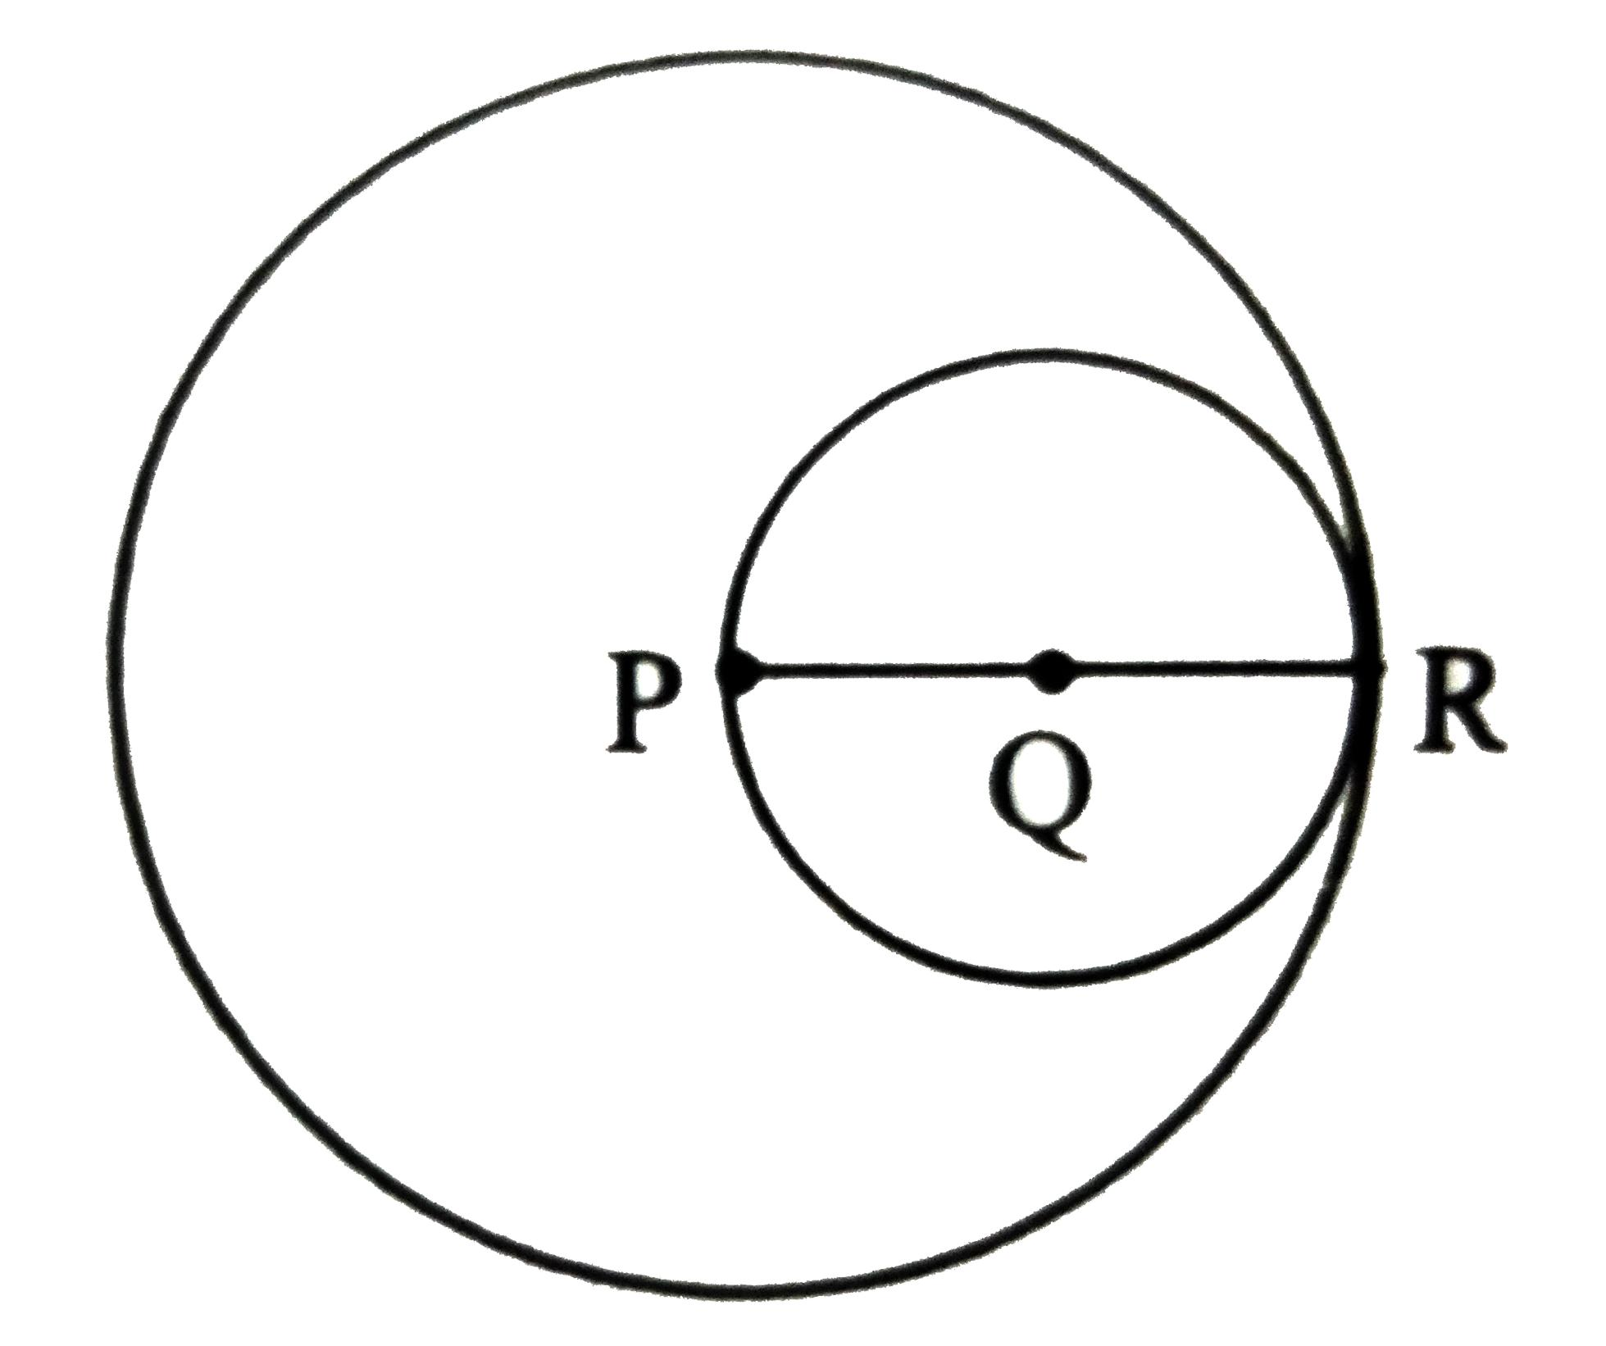
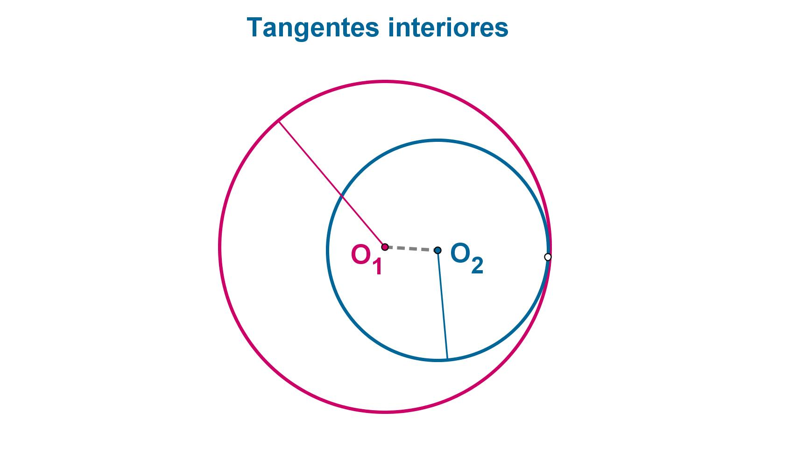
For radii $r_{1}$ and $r_{2}$, where $r_{1}>r_{2}$:
$$\boxed{O_{1}O_{2}=r_{1}-r_{2}}$$
The distance between their centers equals the difference between their radii.

Tangency Between a Circle and a Line
# Source: AI Source: Provided by: [Data Path: Persons Table -> ID Column: 1, Name_En Column: Motasem Essam] -> From: [ChatGPT] on [7/25/2026]
There are three basic relationships between a line and a circle:
1. No Intersection
The line does not touch the circle:
$$\boxed{l∩C=∅}$$
2. Tangency
The line touches the circle at exactly one point:
$$\boxed{l∩C=P}$$
3. Secant Intersection
The line passes through the circle and intersects it at two points:
$$\boxed{l∩C=P,Q}$$
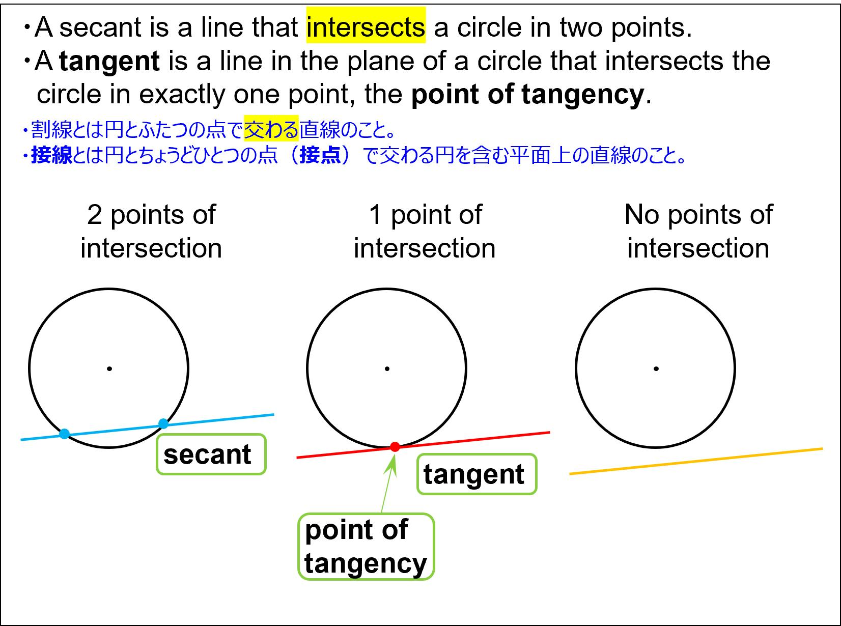
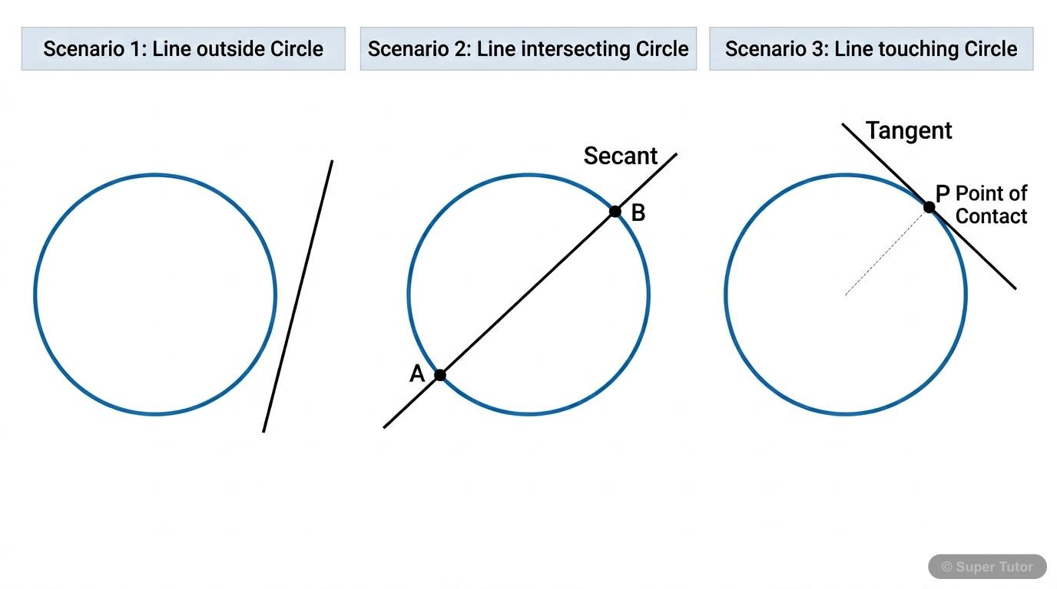
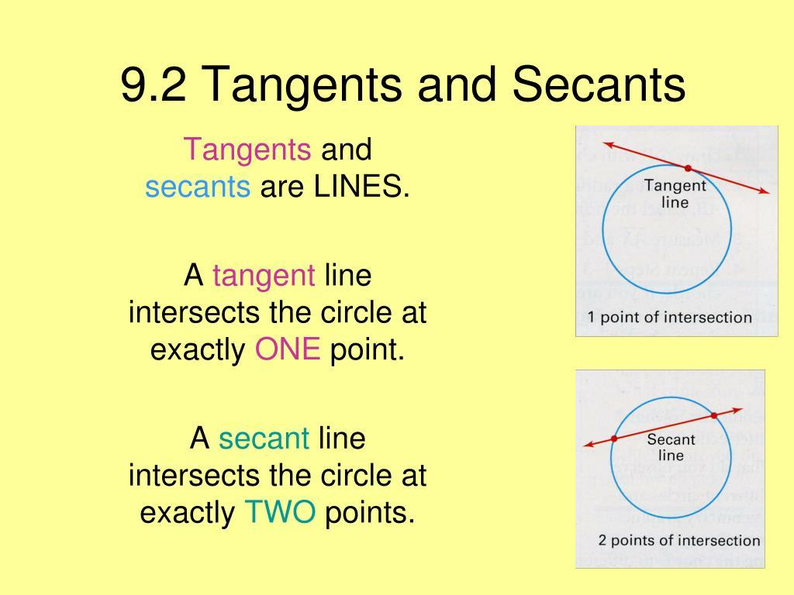
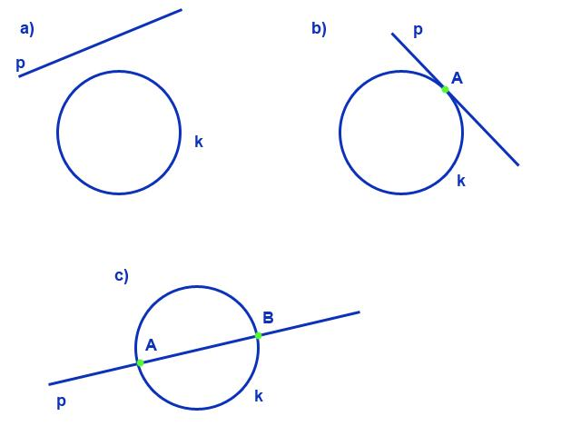
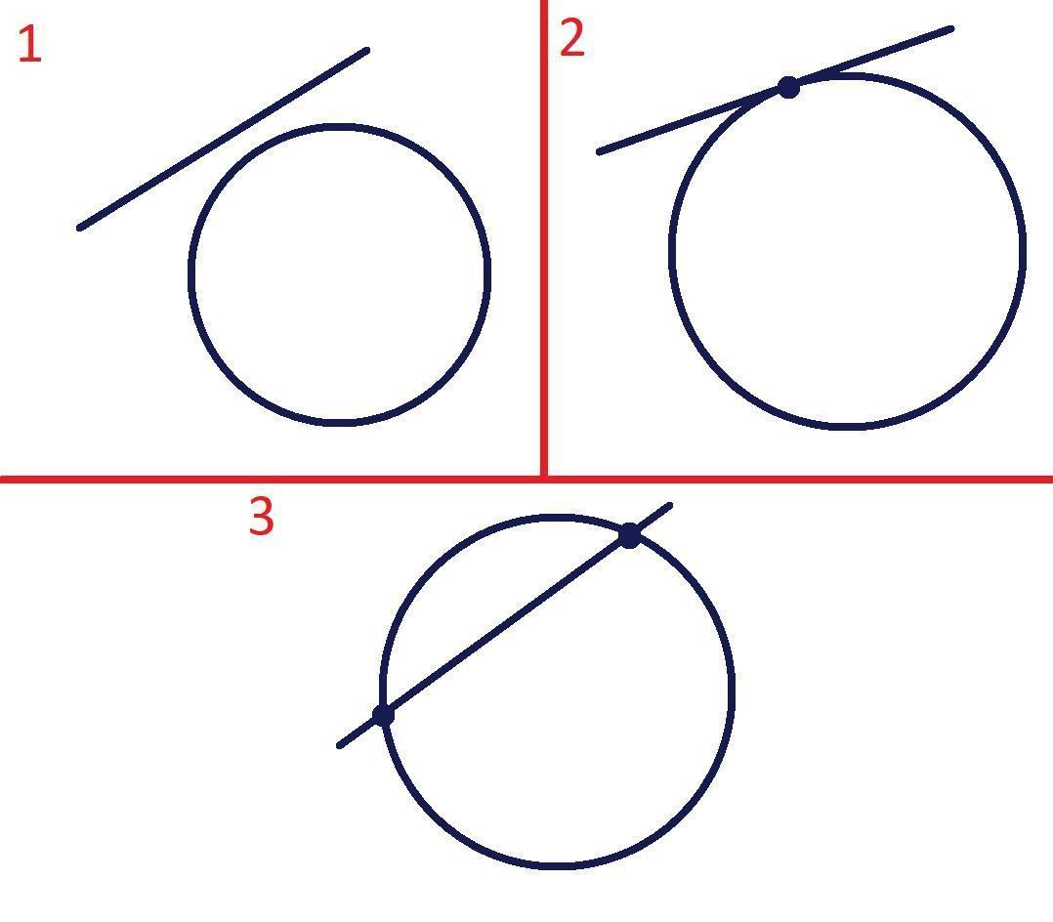

Tangent vs. Secant
# Source: AI Source: Provided by: [Data Path: Persons Table -> ID Column: 1, Name_En Column: Motasem Essam] -> From: [ChatGPT] on [7/25/2026]
A tangent line touches the circle once.
A secant line crosses the circle twice.
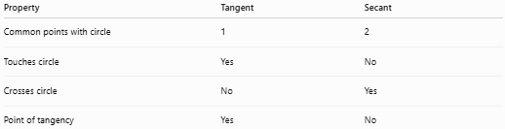
Property | Tangent | Secant
Common points with circle | 1 | 2
Touches circle | Yes | No
Crosses circle | No | Yes
Point of tangency | Yes | No
Therefore:
$$\boxed{\text{Tangent}→1\text{ point}} \\ \boxed{\text{Secant}→2\text{ points}}$$

Tangency and Distance
# Source: AI Source: Provided by: [Data Path: Persons Table -> ID Column: 1, Name_En Column: Motasem Essam] -> From: [ChatGPT] on [7/25/2026]
A line is tangent to a circle when the perpendicular distance from the center to the line equals the radius.
If the circle has radius $r$:
$$\boxed{d\left(O,l\right)=r}$$
where:
- $O$ is the center.
- $l$ is the line.
- $d\left(O,l\right)$ is the perpendicular distance from the center to the line.
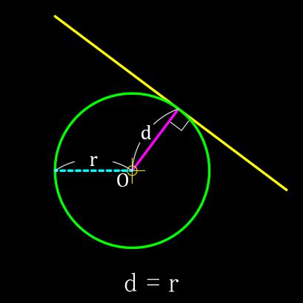
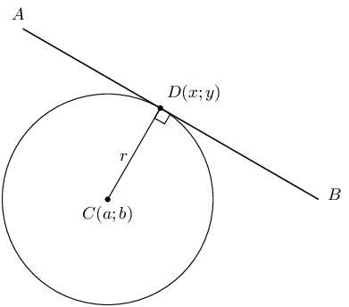
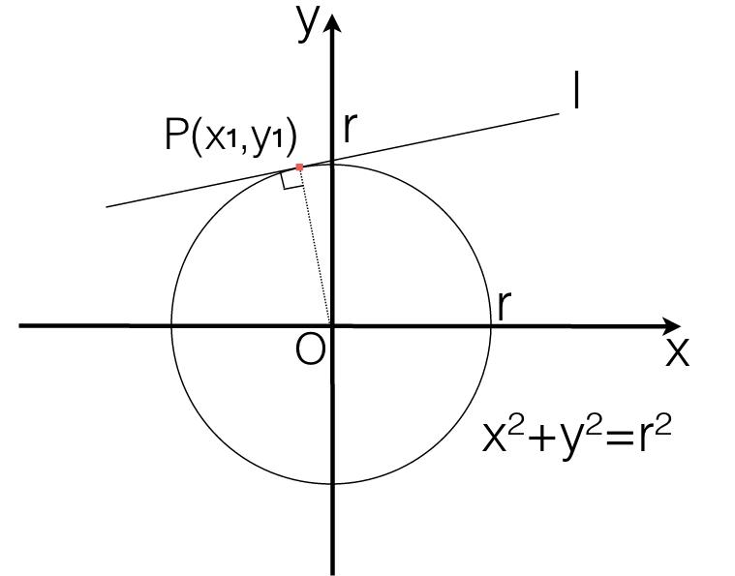

Coordinate Geometry
# Source: AI Source: Provided by: [Data Path: Persons Table -> ID Column: 1, Name_En Column: Motasem Essam] -> From: [ChatGPT] on [7/25/2026]
Consider a circle:
$$x^{2}+y^{2}=r^{2}$$
A line is tangent to the circle if its distance from the center equals the radius.
For a line:
$$Ax+By+C=0$$
and circle center:
$$O=\left(x_{0},y_{0}\right)$$
the distance is:
$$d=\frac{\left|Ax_{0}+By_{0}+C\right|}{\sqrt{A^{2}+B^{2}}}$$
Tangency occurs when:
$$\boxed{\frac{\left|Ax_{0}+By_{0}+C\right|}{\sqrt{A^{2}+B^{2}}}=r}$$

Example
# Source: AI Source: Provided by: [Data Path: Persons Table -> ID Column: 1, Name_En Column: Motasem Essam] -> From: [ChatGPT] on [7/25/2026]
Consider the circle:
$$x^{2}+y^{2}=25$$
Its center is:
$$O=\left(0,0\right)$$
and radius:
$$r=5$$
Consider the line:
$$y=5$$
Written in standard form:
$$y-5=0$$
The distance from the center to the line is:
$$d=\frac{\left|0-5\right|}{1}=5$$
Since:
$$d=r$$
the line is tangent to the circle.
Therefore:
$$\boxed{y=5\text{ is tangent to }x^{2}+y^{2}=25}$$

Tangent Segments From an External Point
# Source: AI Source: Provided by: [Data Path: Persons Table -> ID Column: 1, Name_En Column: Motasem Essam] -> From: [ChatGPT] on [7/25/2026]
Suppose a point $P$ is outside a circle and two tangent segments are drawn from $P$.
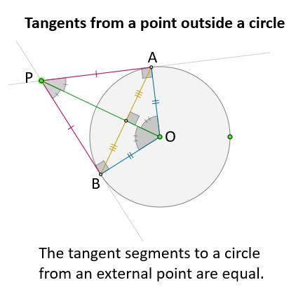
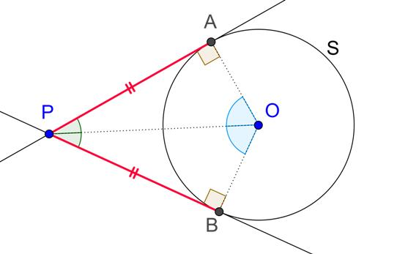
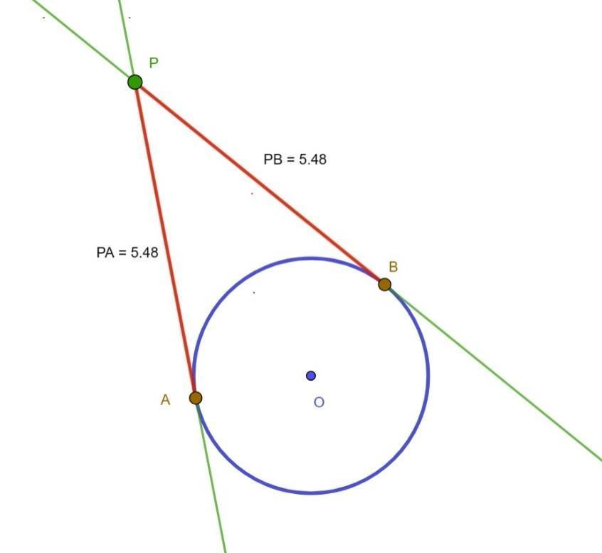
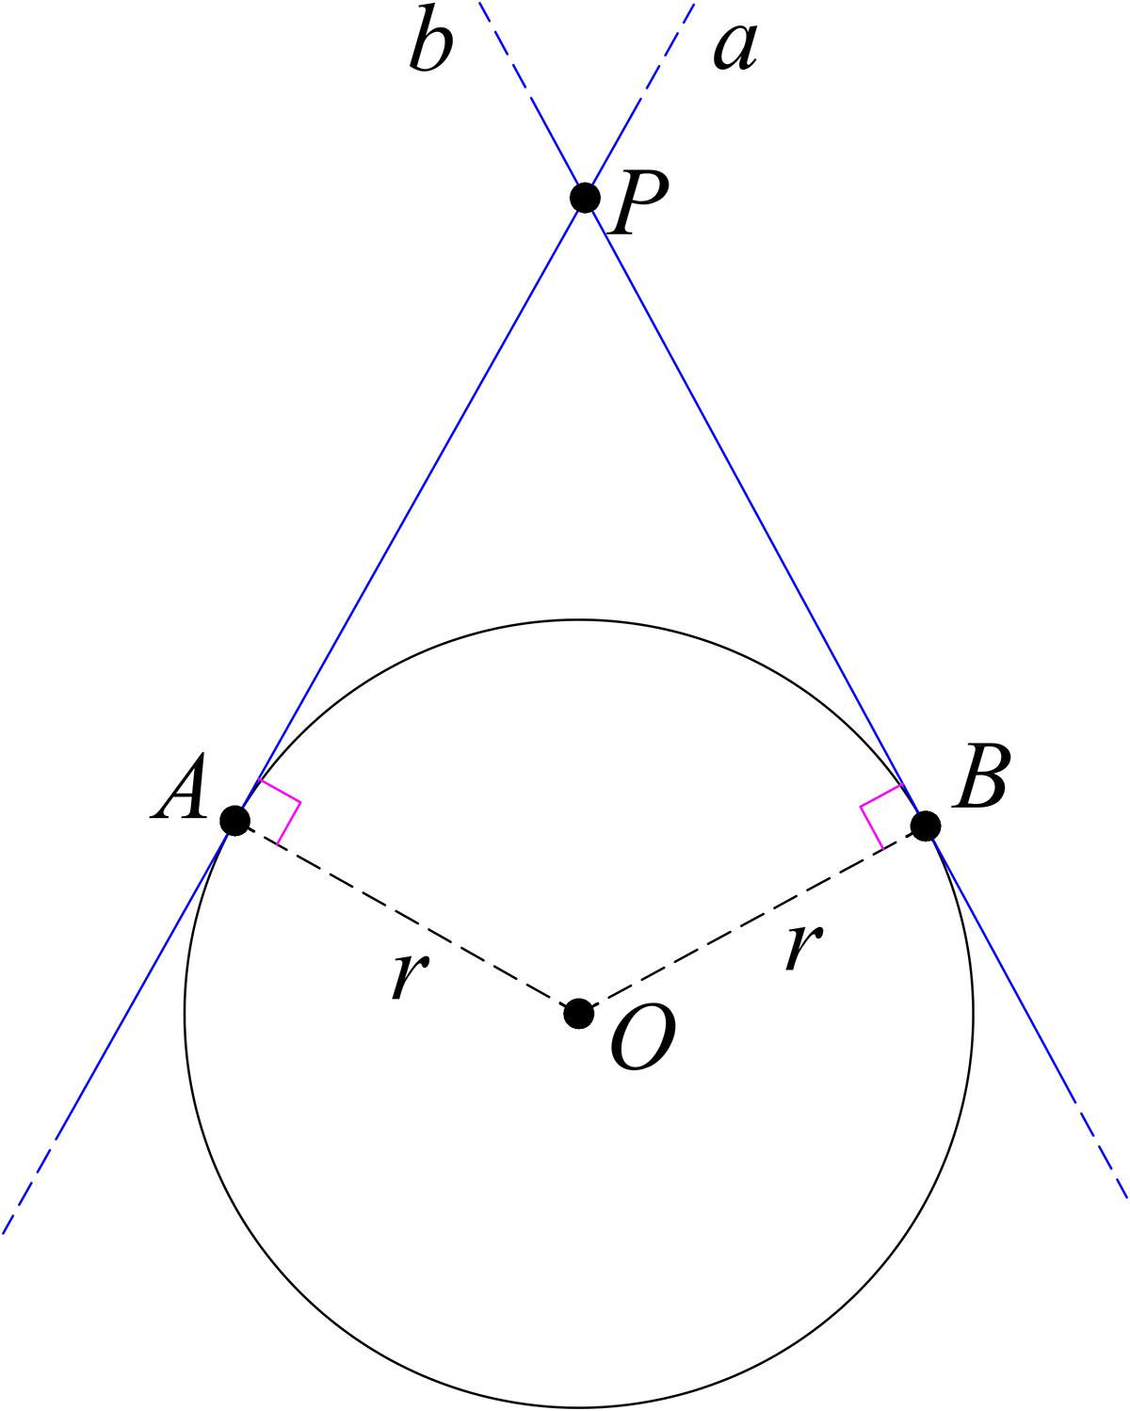
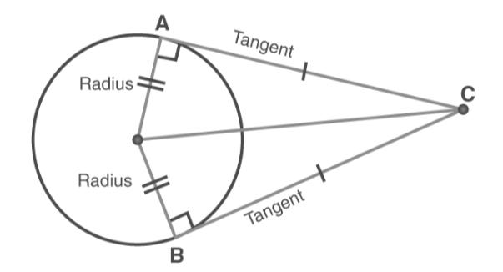
If the tangent points are $A$ and $B$, then:
$$\boxed{PA=PB}$$
Thus, tangent segments drawn from the same external point have equal lengths.

Tangent and Radius Relationship
# Source: AI Source: Provided by: [Data Path: Persons Table -> ID Column: 1, Name_En Column: Motasem Essam] -> From: [ChatGPT] on [7/25/2026]
If a tangent touches a circle at $P$, the radius $OP$ is perpendicular to the tangent:
$$\boxed{OP⊥l}$$
Therefore:
$$\boxed{∠OPQ={90}^{∘}}$$
where $PQ$ lies along the tangent line.

Tangency Between Curves
# Source: AI Source: Provided by: [Data Path: Persons Table -> ID Column: 1, Name_En Column: Motasem Essam] -> From: [ChatGPT] on [7/25/2026]
Tangency is not limited to circles and lines.
Two curves can also be tangent if they touch at a point and have the same tangent direction there.
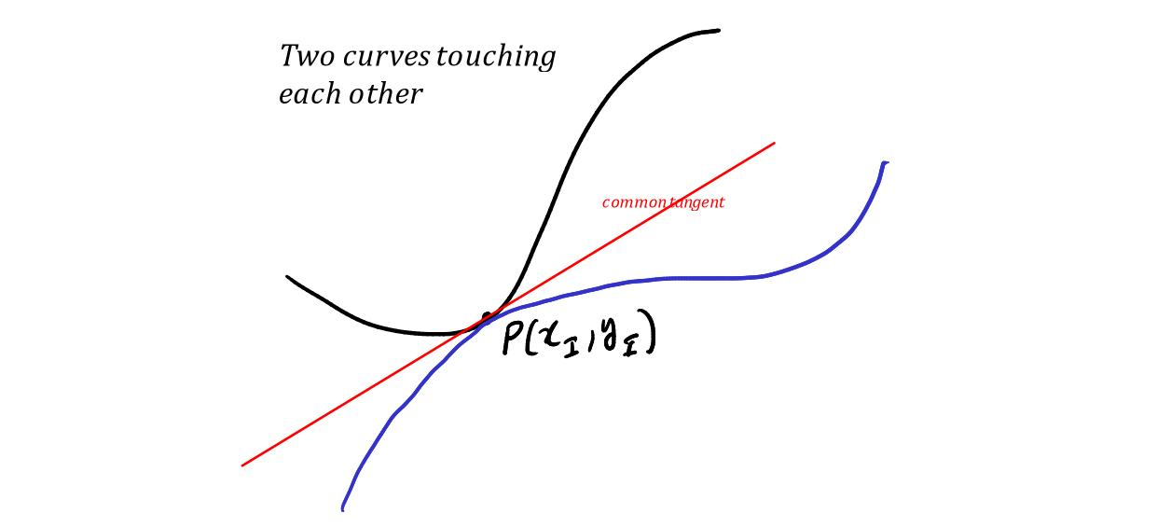
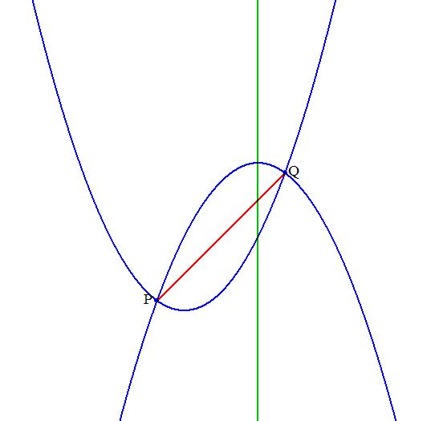
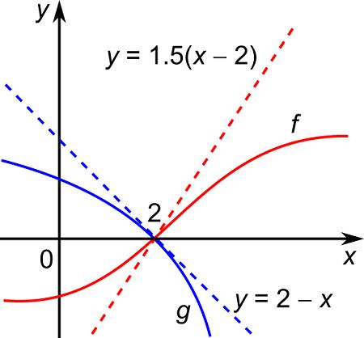
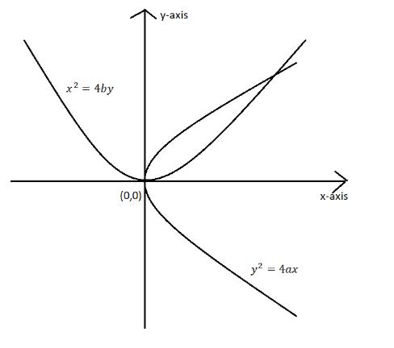
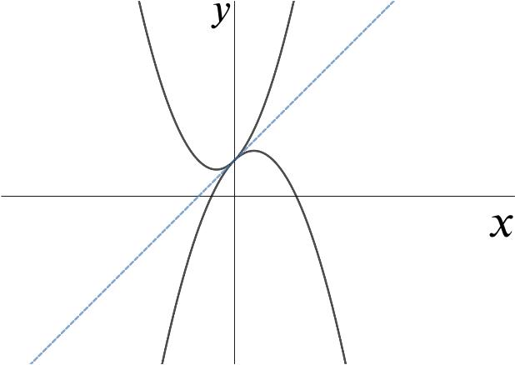
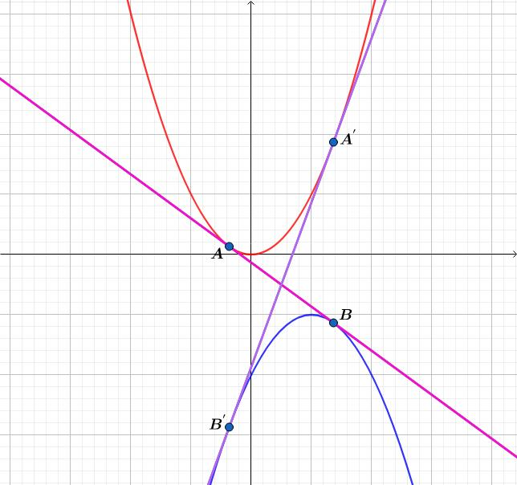
At the point of tangency $P$:
$$\boxed{\text{Tangent directions are the same}}$$
In calculus, this can be described using equal derivatives:
$$\boxed{f^{'}\left(x_{0}\right)=g^{'}\left(x_{0}\right)}$$
when the curves meet at $x_{0}$.

Tangency vs. Crossing
# Source: AI Source: Provided by: [Data Path: Persons Table -> ID Column: 1, Name_En Column: Motasem Essam] -> From: [ChatGPT] on [7/25/2026]
Tangency and crossing are different relationships.
Tangency
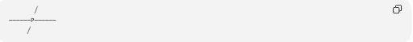
╱
──────P──────
╱
The curves touch at (P) without crossing through each other.
Crossing

\ /
\ /
\ /
P
/ \
/ \
The curves pass through each other.
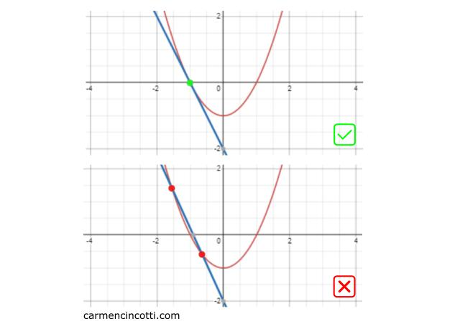
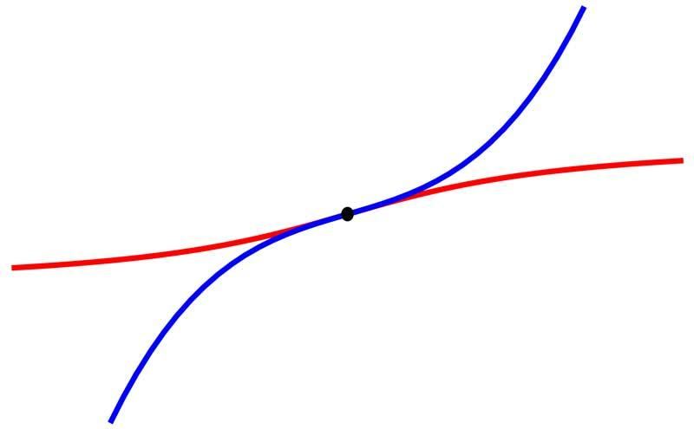
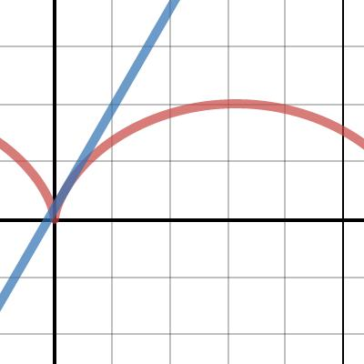

Tangency and Intersection
# Source: AI Source: Provided by: [Data Path: Persons Table -> ID Column: 1, Name_En Column: Motasem Essam] -> From: [ChatGPT] on [7/25/2026]
Tangency can be considered a special type of intersection.
For a tangent line and circle:
$$\boxed{l∩C=P}$$
There is one common point, but the objects do not cross at that point.
Therefore:
$$\boxed{\text{Tangency}=\text{One-point contact without crossing}}$$

Tangency of Two Circles
# Source: AI Source: Provided by: [Data Path: Persons Table -> ID Column: 1, Name_En Column: Motasem Essam] -> From: [ChatGPT] on [7/25/2026]
For two circles:
External Tangency
$$\boxed{d=r_{1}+r_{2}}$$
Internal Tangency
$$\boxed{d=\left|r_{1}-r_{2}\right|}$$
where:
$$d=O_{1}O_{2}$$
is the distance between the centers.
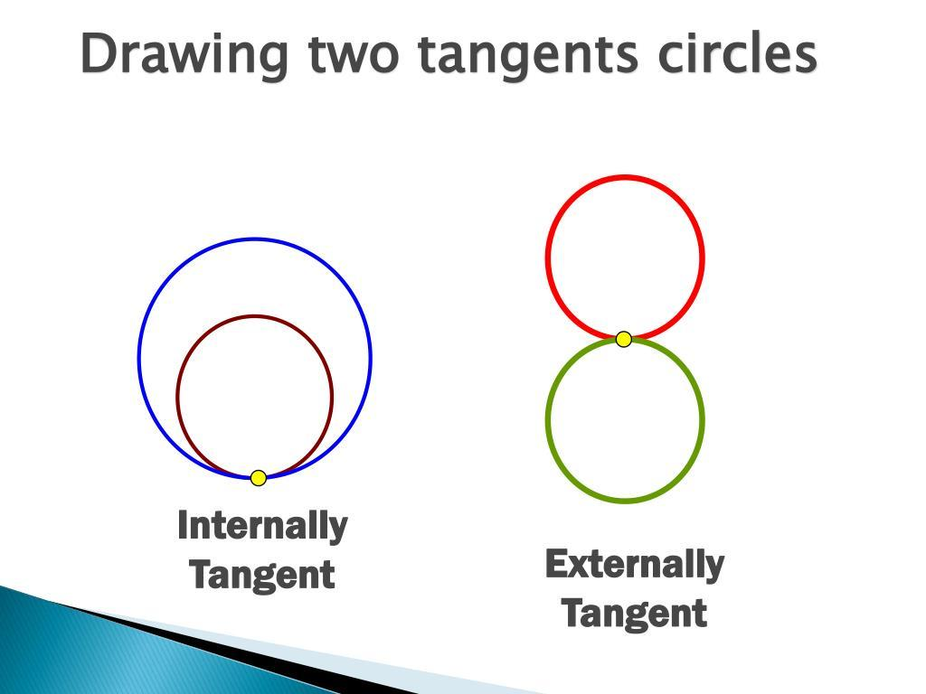
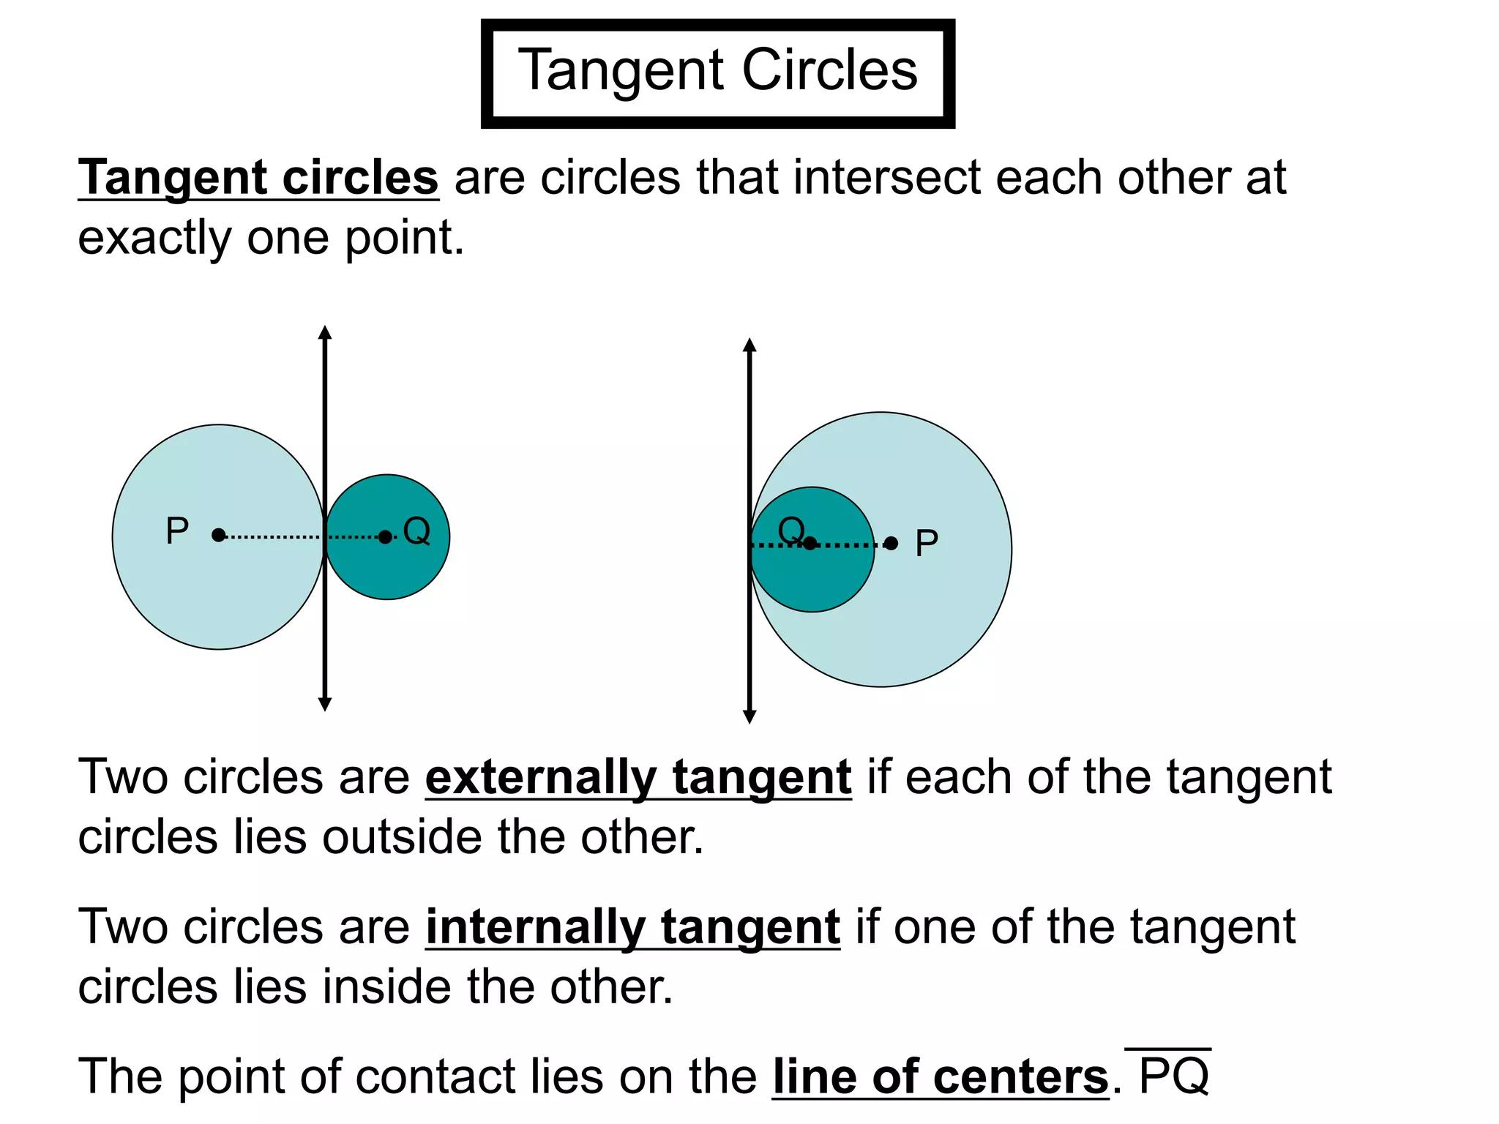
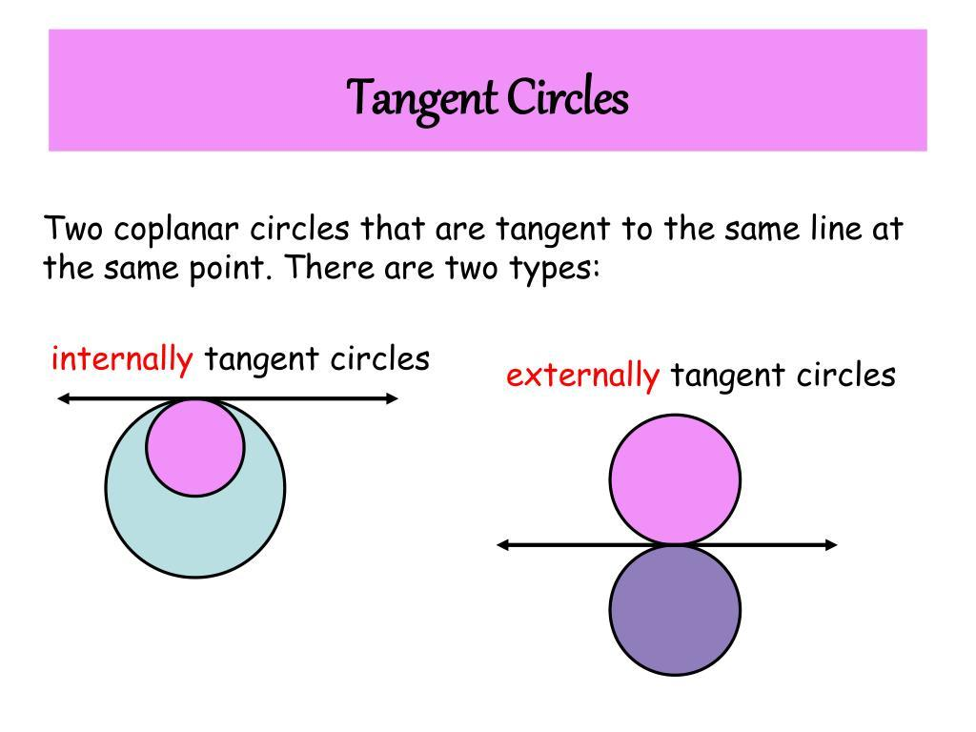
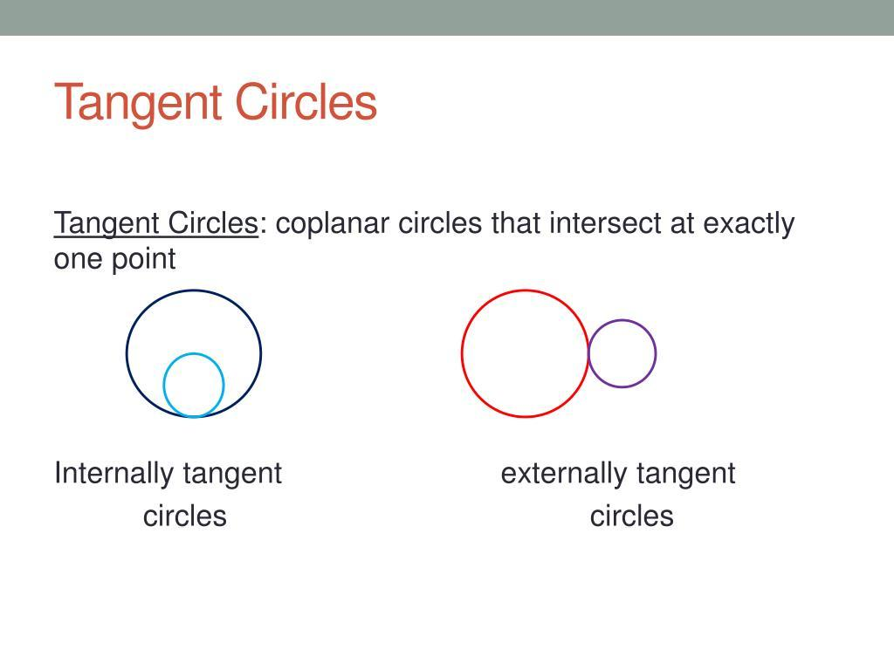

Tangency of Two Circles vs. Two Intersecting Circles
# Source: AI Source: Provided by: [Data Path: Persons Table -> ID Column: 1, Name_En Column: Motasem Essam] -> From: [ChatGPT] on [7/25/2026]
Two circles can have:
No Intersection
$$\boxed{d>r_{1}+r_{2}}$$
for externally separated circles.
External Tangency
$$\boxed{d=r_{1}+r_{2}}$$
Two-Point Intersection
$$\boxed{\left|r_{1}-r_{2}\right|<d<r_{1}+r_{2}}$$
Internal Tangency
$$\boxed{d=\left|r_{1}-r_{2}\right|}$$
No Intersection — One Inside Another
$$\boxed{d<\left|r_{1}-r_{2}\right|}$$
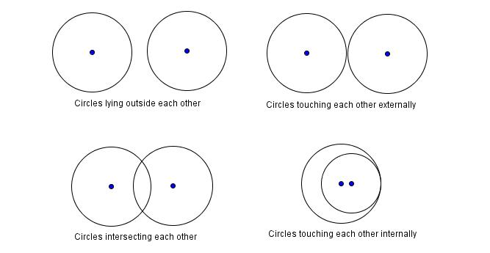
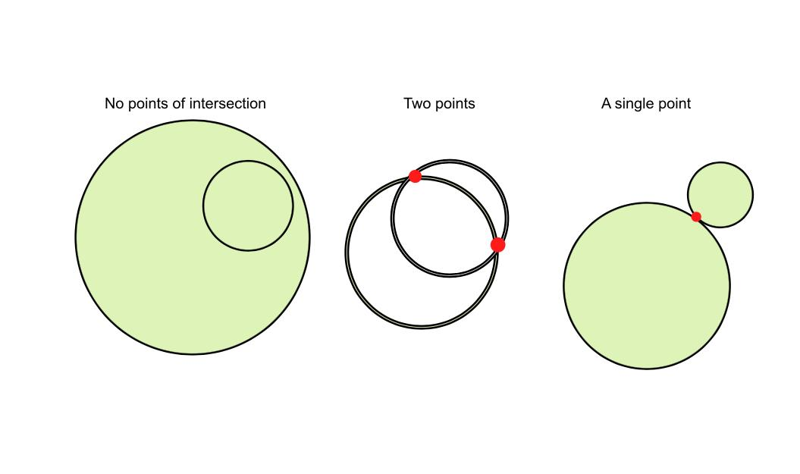
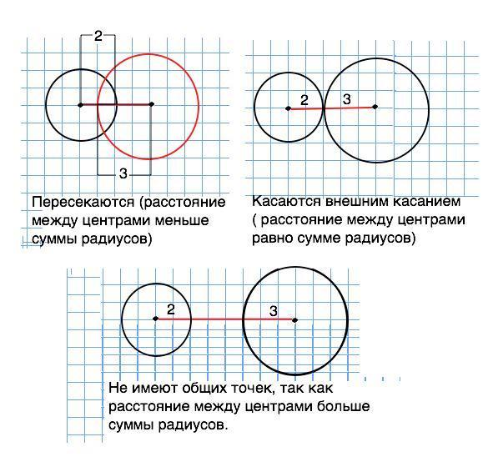

Tangency in Polygons
# Source: AI Source: Provided by: [Data Path: Persons Table -> ID Column: 1, Name_En Column: Motasem Essam] -> From: [ChatGPT] on [7/25/2026]
A circle can be tangent to the sides of a polygon.
For example, a circle inside a triangle can touch all three sides.
Such a circle is called an incircle.
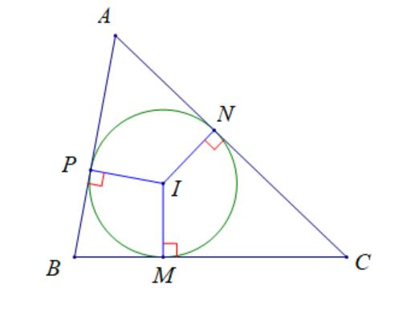
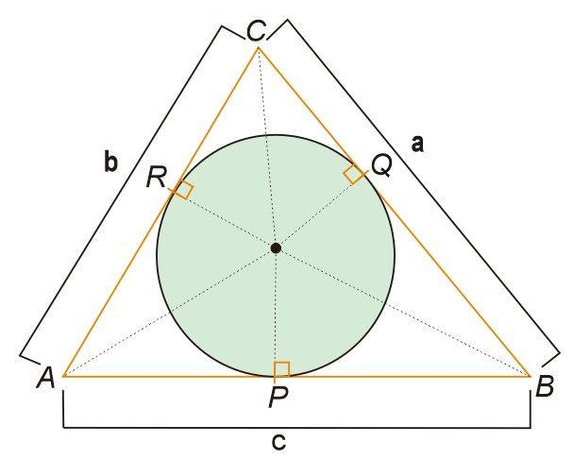
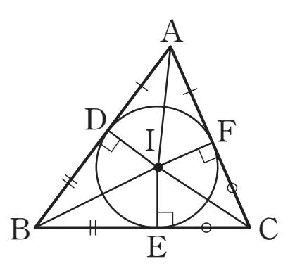
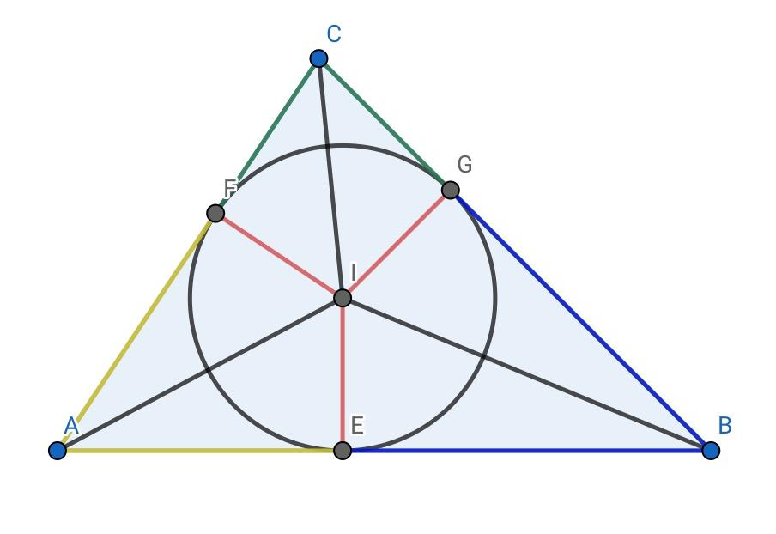
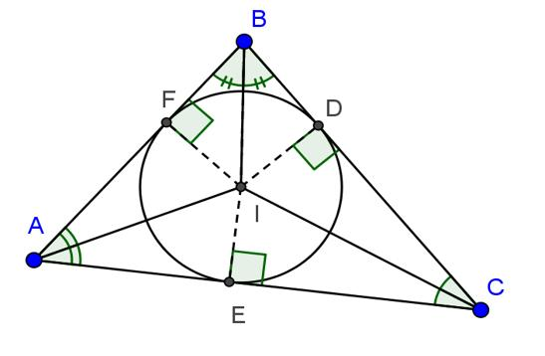
The circle is tangent to each side at a point.

Tangency to a Circle
# Source: AI Source: Provided by: [Data Path: Persons Table -> ID Column: 1, Name_En Column: Motasem Essam] -> From: [ChatGPT] on [7/25/2026]
A polygon can also surround a circle such that every side is tangent to the circle.
This is called a circumscribed polygon around the circle.
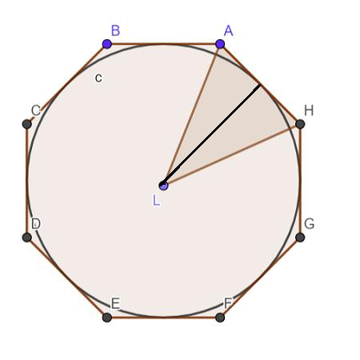
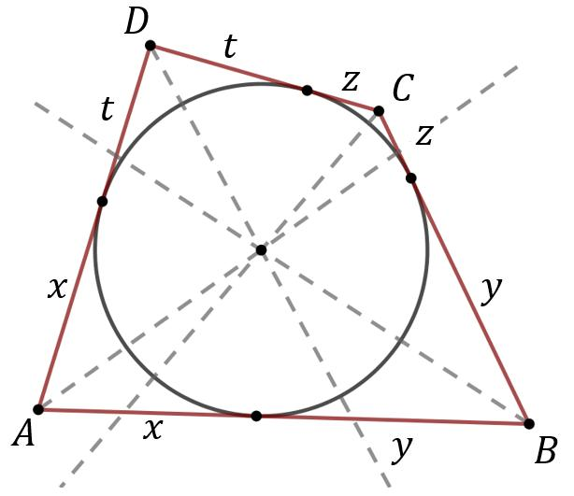
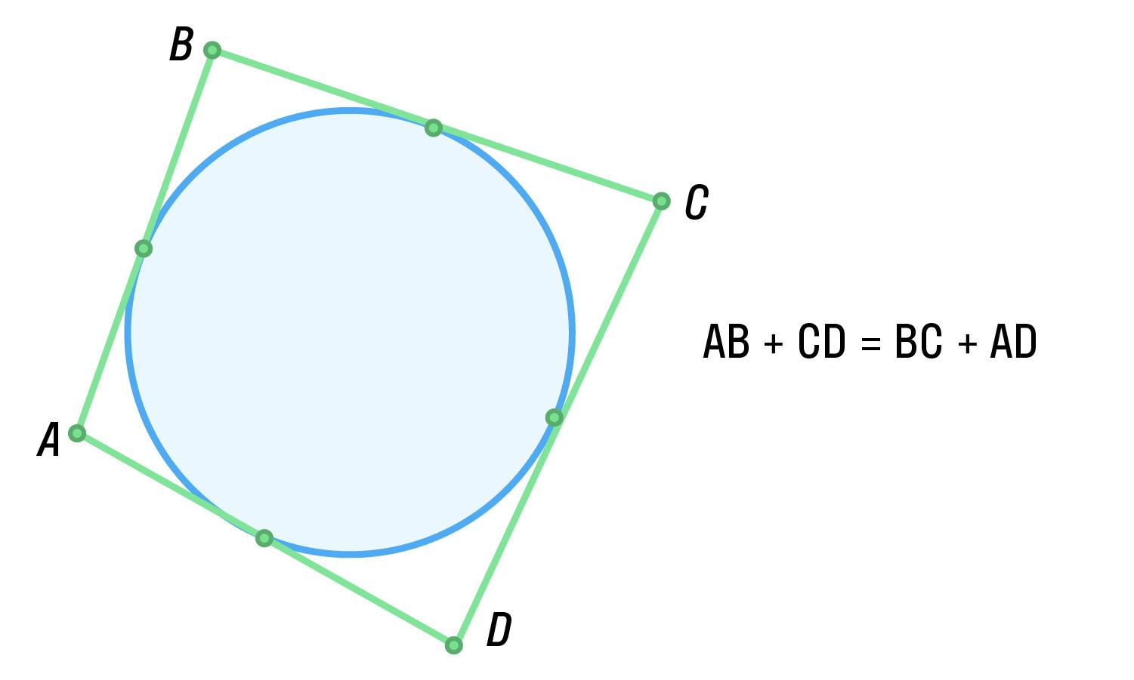
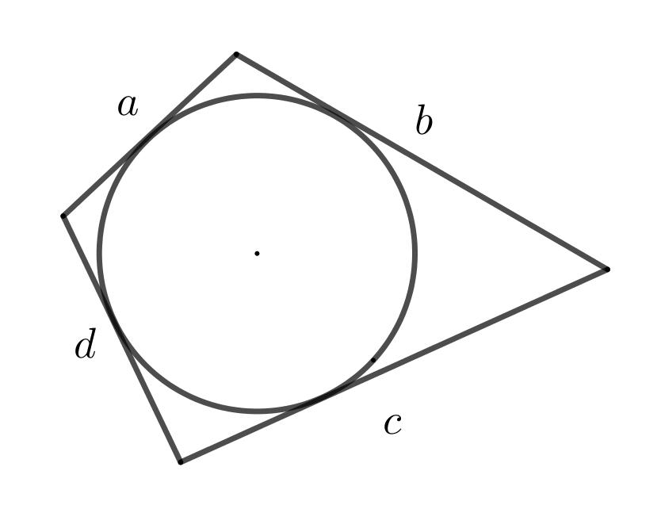
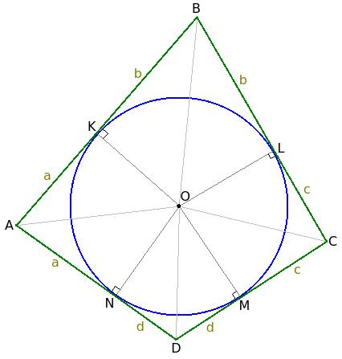

Tangency in Architecture and Engineering
# Source: AI Source: Provided by: [Data Path: Persons Table -> ID Column: 1, Name_En Column: Motasem Essam] -> From: [ChatGPT] on [7/25/2026]
Tangency is important when designing smooth connections between geometric elements.
Examples include:
- Circular roads.
- Curved bridges.
- Mechanical components.
- Pipes.
- Wheels.
- Gears.
- Machine parts.
- Architectural curves.
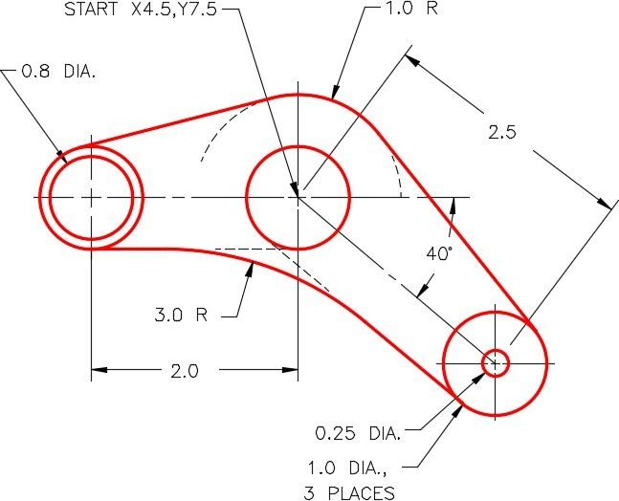
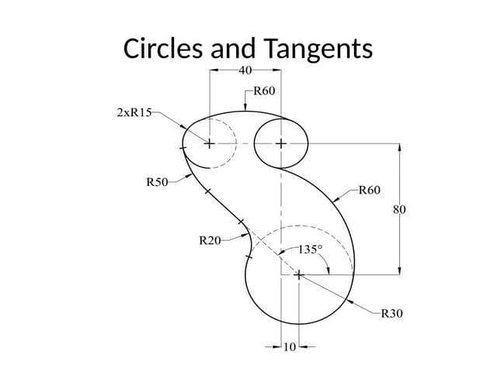
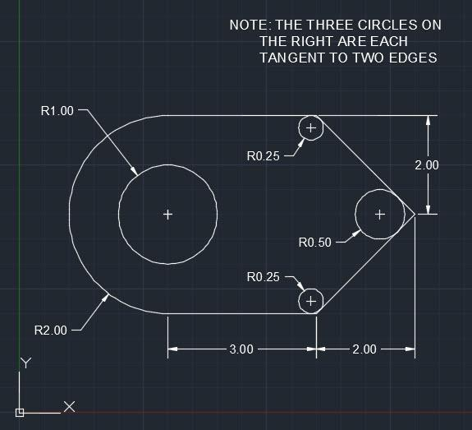
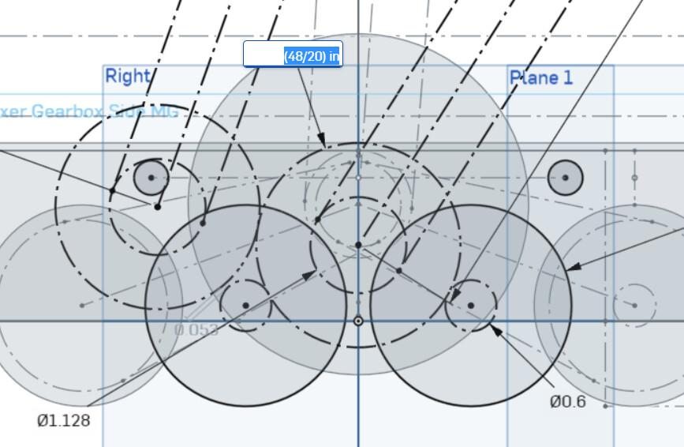
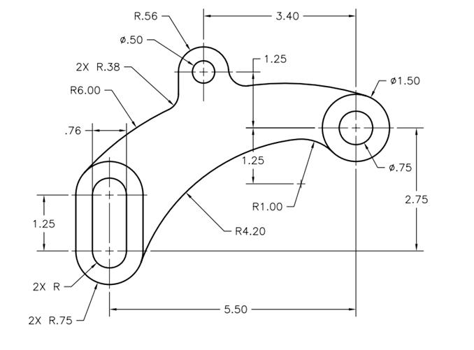

Tangency in CAD
# Source: AI Source: Provided by: [Data Path: Persons Table -> ID Column: 1, Name_En Column: Motasem Essam] -> From: [ChatGPT] on [7/25/2026]
CAD systems frequently use tangent constraints.
A tangent constraint ensures that two curves or geometric objects touch smoothly without forming a sharp directional change.
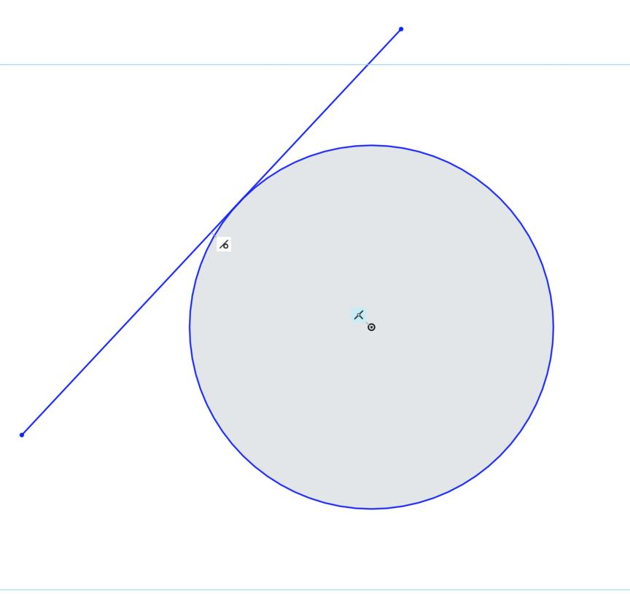
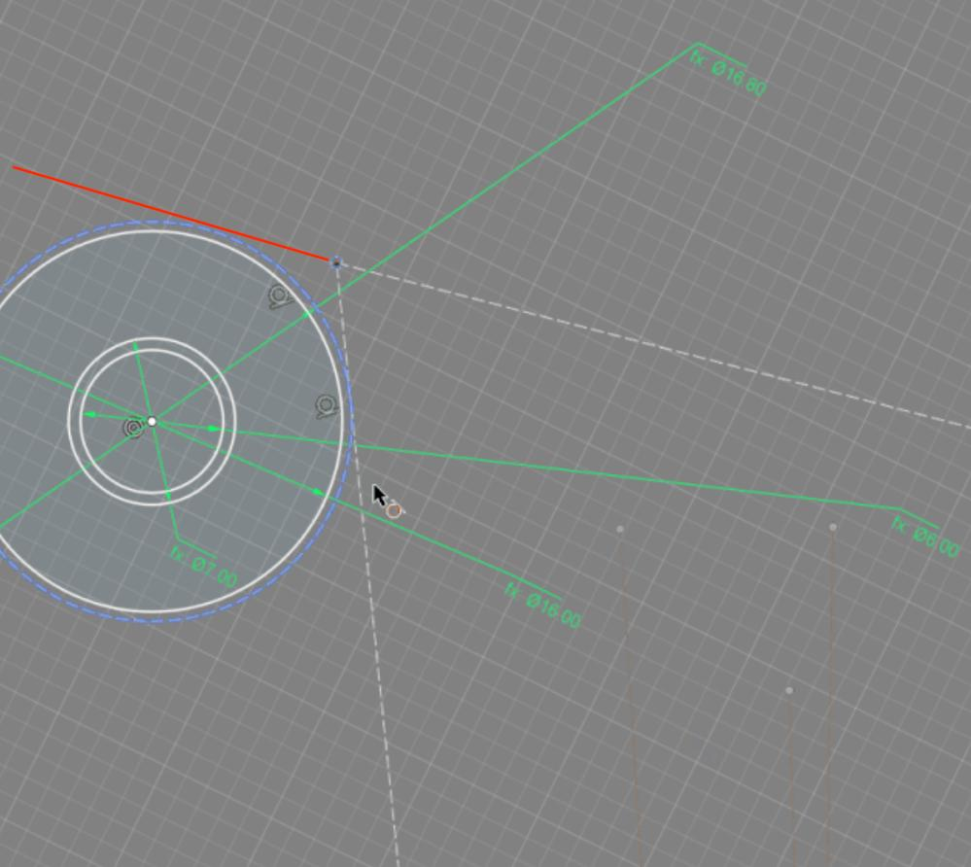
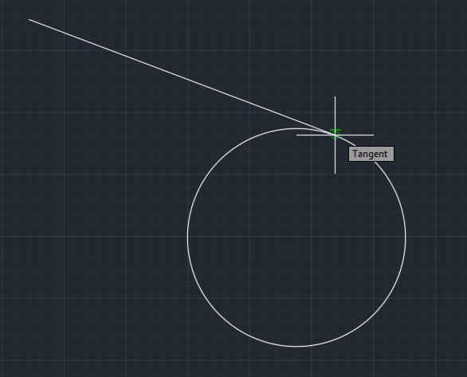
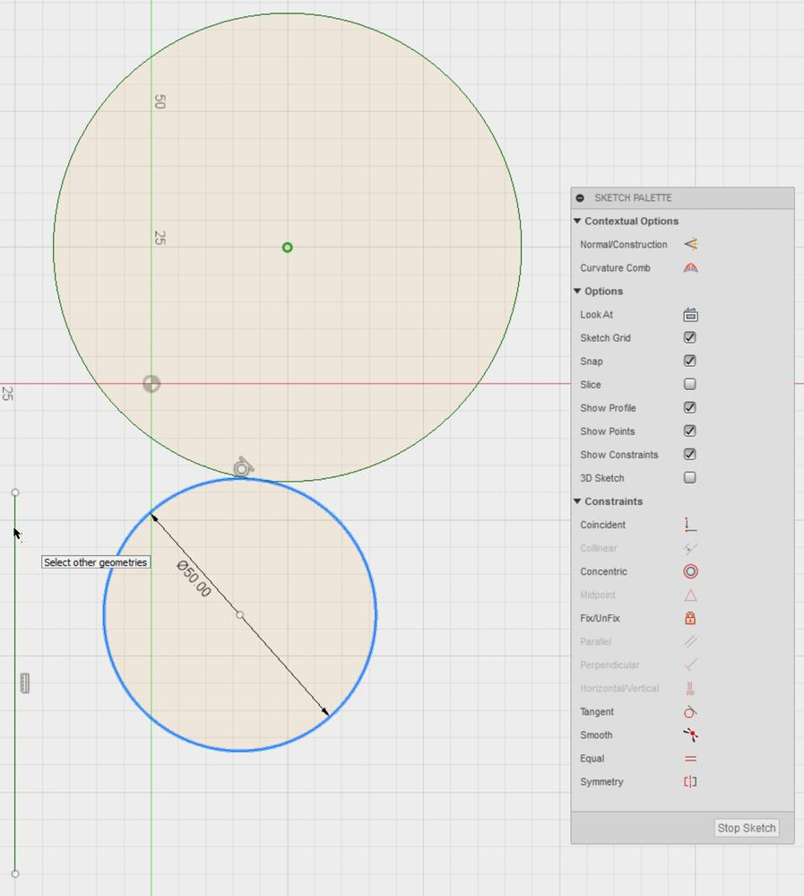
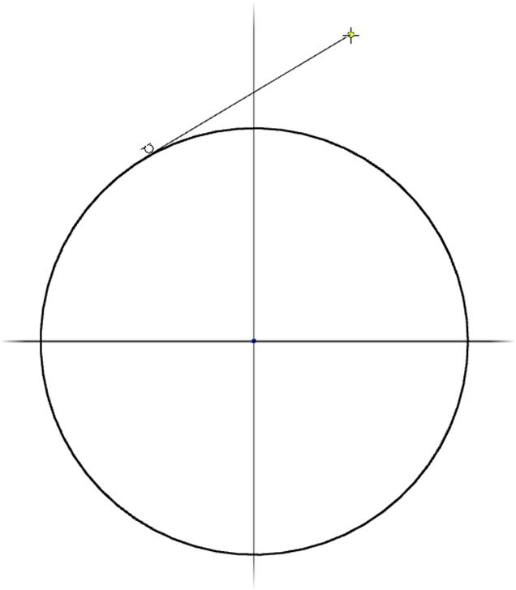
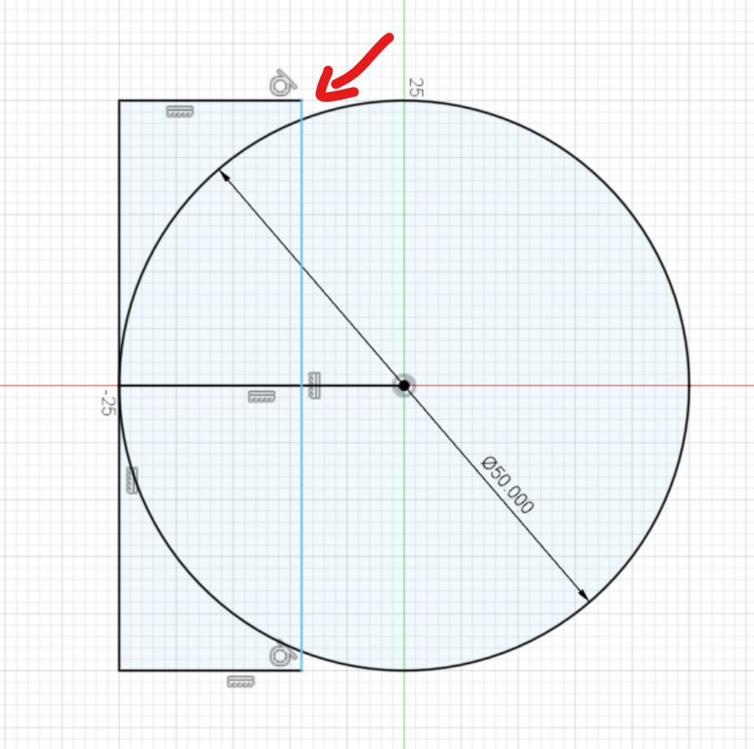
Tangency constraints are useful for:
- Mechanical design.
- Product design.
- Engineering drawings.
- Smooth curves.
- Fillets.
- Circular components.

Tangency in Computer Graphics
# Source: AI Source: Provided by: [Data Path: Persons Table -> ID Column: 1, Name_En Column: Motasem Essam] -> From: [ChatGPT] on [7/25/2026]
Tangency is used to create smooth transitions between curves and surfaces.
Applications include:
- Vector graphics.
- Curve modeling.
- Animation.
- CAD.
- Computer-aided design.
- Shape generation.

Real-World Examples
# Source: AI Source: Provided by: [Data Path: Persons Table -> ID Column: 1, Name_En Column: Motasem Essam] -> From: [ChatGPT] on [7/25/2026]
Tangency appears in:
- A wheel touching a flat road.
- A ball touching a surface.
- A circular gear touching another gear.
- A curved road joining a straight road.
- A pipe touching another circular component.
- A circle touching the sides of a shape.
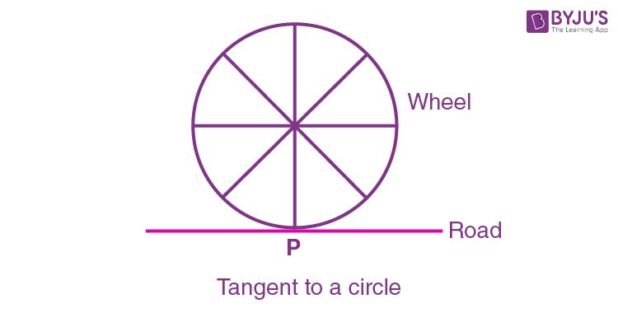
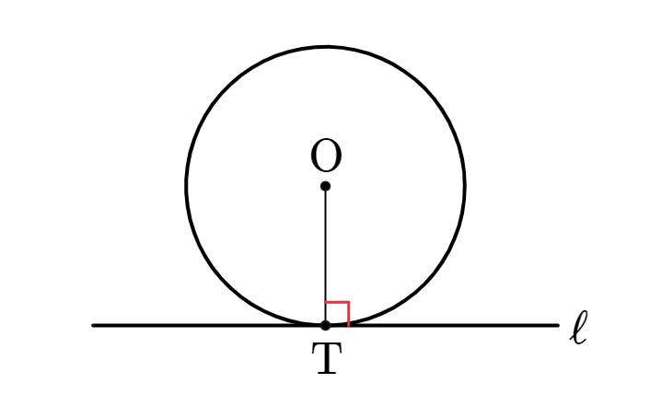
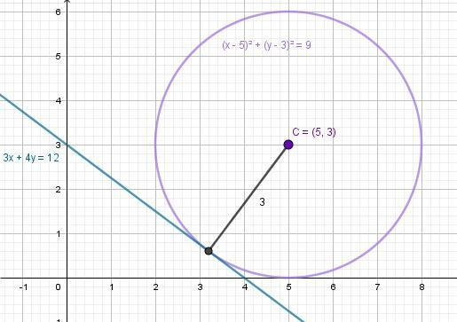
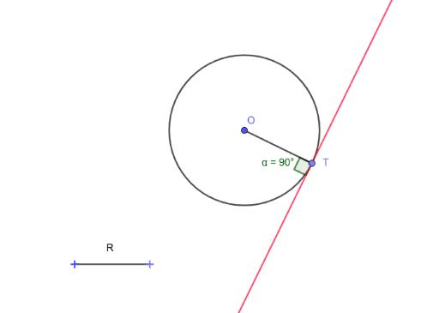

Applications
# Source: AI Source: Provided by: [Data Path: Persons Table -> ID Column: 1, Name_En Column: Motasem Essam] -> From: [ChatGPT] on [7/25/2026]
Tangency is important in:
- Plane Geometry
- Circle Geometry
- Coordinate Geometry
- Euclidean Geometry
- Trigonometry
- Calculus
- CAD
- Architecture
- Engineering
- Computer Graphics
- Robotics
- Road Design
- Mechanical Design

Advantages
# Source: AI Source: Provided by: [Data Path: Persons Table -> ID Column: 1, Name_En Column: Motasem Essam] -> From: [ChatGPT] on [7/25/2026]
Studying tangency helps to:
- Analyze contact between objects.
- Construct tangent lines.
- Calculate geometric distances.
- Determine circle relationships.
- Create smooth curves.
- Design mechanical components.
- Solve geometry problems.
- Model engineering structures.
- Create smooth transitions in CAD.

Limitations
# Source: AI Source: Provided by: [Data Path: Persons Table -> ID Column: 1, Name_En Column: Motasem Essam] -> From: [ChatGPT] on [7/25/2026]
Tangency:
- Usually requires precise geometric conditions.
- Can be difficult to determine from approximate measurements.
- Must be distinguished from ordinary crossing.
- May require coordinate or algebraic calculations.
- In computer systems, floating-point errors can make exact tangency difficult to detect.

Comparison with Related Concepts
# Source: AI Source: Provided by: [Data Path: Persons Table -> ID Column: 1, Name_En Column: Motasem Essam] -> From: [ChatGPT] on [7/25/2026]
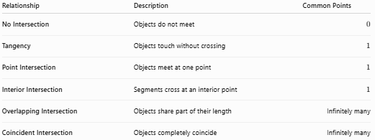
Relationship | Description | Common Points
No Intersection | Objects do not meet | $$0$$
Tangency | Objects touch without crossing | $$1$$
Point Intersection | Objects meet at one point | $$1$$
Interior Intersection | Segments cross at an interior point | $$1$$
Overlapping Intersection | Objects share part of their length | Infinitely many
Coincident Intersection | Objects completely coincide | Infinitely many

Key Points
# Source: AI Source: Provided by: [Data Path: Persons Table -> ID Column: 1, Name_En Column: Motasem Essam] -> From: [ChatGPT] on [7/25/2026]
- Tangency is a geometric relationship where two objects touch at exactly one point without crossing.
- The common point is called the point of tangency.
- A tangent line to a circle touches it at exactly one point.
- The radius to the point of tangency is perpendicular to the tangent:
$$\boxed{OP⊥l}$$
- The angle between the radius and tangent is:
$$\boxed{{90}^{∘}}$$
- Two circles can be:
  - Externally tangent.
  - Internally tangent.
- External tangency:
$$\boxed{d=r_{1}+r_{2}}$$
- Internal tangency:
$$\boxed{d=\left|r_{1}-r_{2}\right|}$$
- Tangency is widely used in geometry, engineering, CAD, architecture, road design, mechanical design, and computer graphics.

Conclusion
# Source: AI Source: Provided by: [Data Path: Persons Table -> ID Column: 1, Name_En Column: Motasem Essam] -> From: [ChatGPT] on [7/25/2026]
Tangency is a geometric relationship in which two geometric objects touch at exactly one common point without crossing each other at that point. The common point is called the point of tangency. The most familiar example is a tangent line touching a circle, where the radius drawn to the point of tangency is perpendicular to the tangent line. Tangency can also occur between two circles, curves, polygon sides, and other geometric objects. It is an important concept in plane geometry, coordinate geometry, circle geometry, calculus, engineering, architecture, CAD, road design, mechanical design, and computer graphics.

